http://planeta42.com

https://www.game.store.bg › search

https://chemistrynetwork.pixel-online.org › files
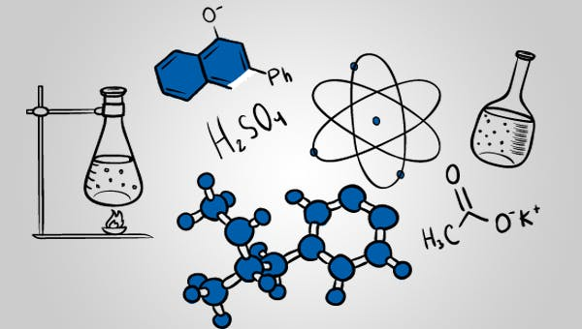

https://uchmag.com

