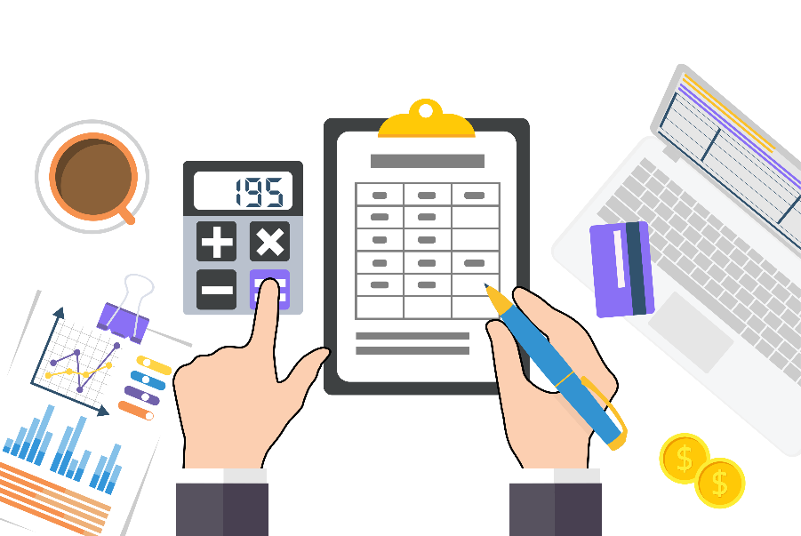
https://www.fakturirane.bg/

https://www.tita.bg/free

https://nra.bg/

https://www.nssi.bg/

https://www.msoft.bg/info_law.php?id=21

https://balans.bg/lib/praktichesko-schetovodstvo

