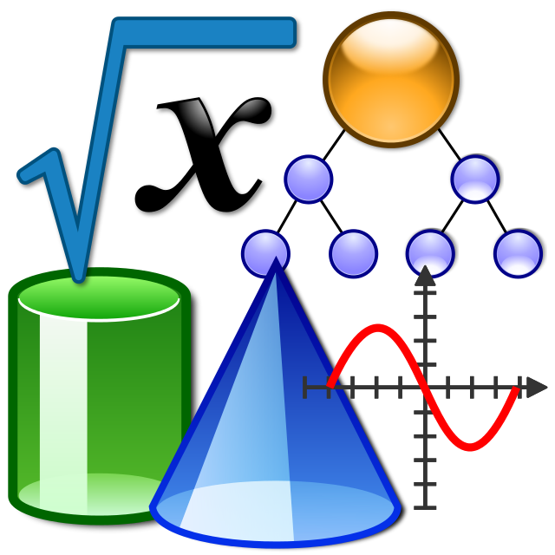
https://learningapps.org/index.php?page=1&s=&category=2

https://create.kahoot.it/search?query=Math

https://bg.khanacademy.org/math

